TRAVERTIME
Dutch Fusion Jazz

Introduction
Hello! We are 6-man band Travertime. We make organic music: with heads, hands and feet indeed. Call it jazz. Call it fusion. Call it anything you like. Being instrumentalists we’re lost for words anyway.

We do aspire to inspire to stir up spirits, mesmerize minds, mix emotions and feed the soul. If that makes sense. If not, sorry, we can't help it and do it anyway.

So… tap your feet, nod your head, hum along, cry for joy or ease your pain, whatever you feel resonates with your game.

We deeply appreciate you lending us your eyes and ears and look forward to meeting you and sharing a great time. And remember, it's always Travertime.

Travertime,
Steffen 't Hart - Keys & compositions
Steven Dietvorst - Saxes
Wouter Klück - Trumpets
Leo Sienot - Guitars
Amand de Ligt - Drums
Willem de Koning - Basses

Contact:

Steffen 0622525920
Willem 0653981249

E-mail

steffenthart@gmail.com
will4bass@gmail.com

Description
Travertime is a 6-man band, or a double Dutch trio if you will, making organic music that tends to be recognized as jazz, fusion and similar sonic movements. Old school roots and contemporary vibes form an accessible whole with plenty of room for interpretation.

Description short
Travertime is a 6-man band making organic music that tends to be recognized as contemporary jazz, fusion and similar sonic movements.

Description supershort
Dutch fusion and jazz: Travertime. Wholesome organic earfood.

Description not
.

Socials & streaming links



Media download/press kit:

Pictures
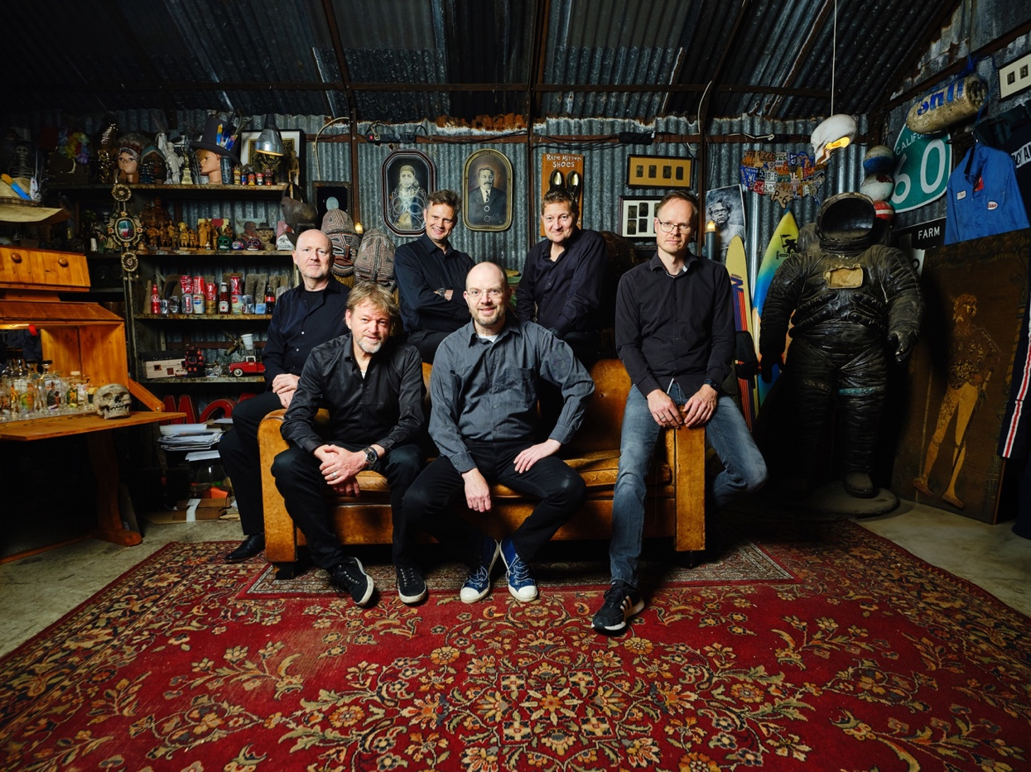

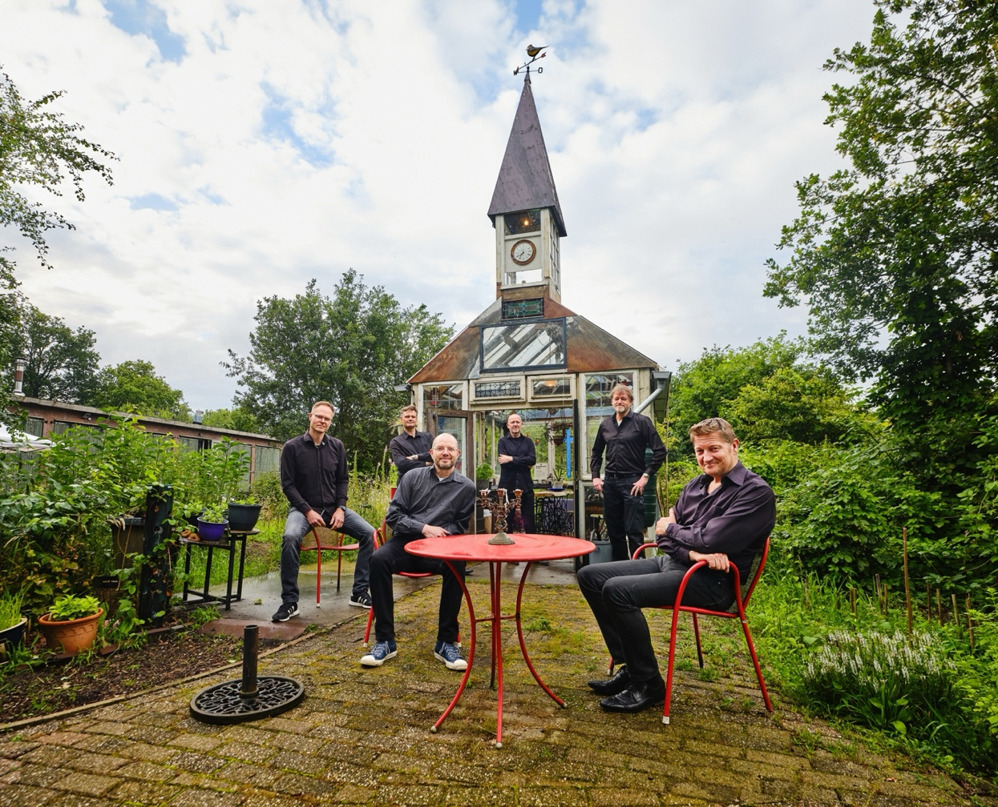
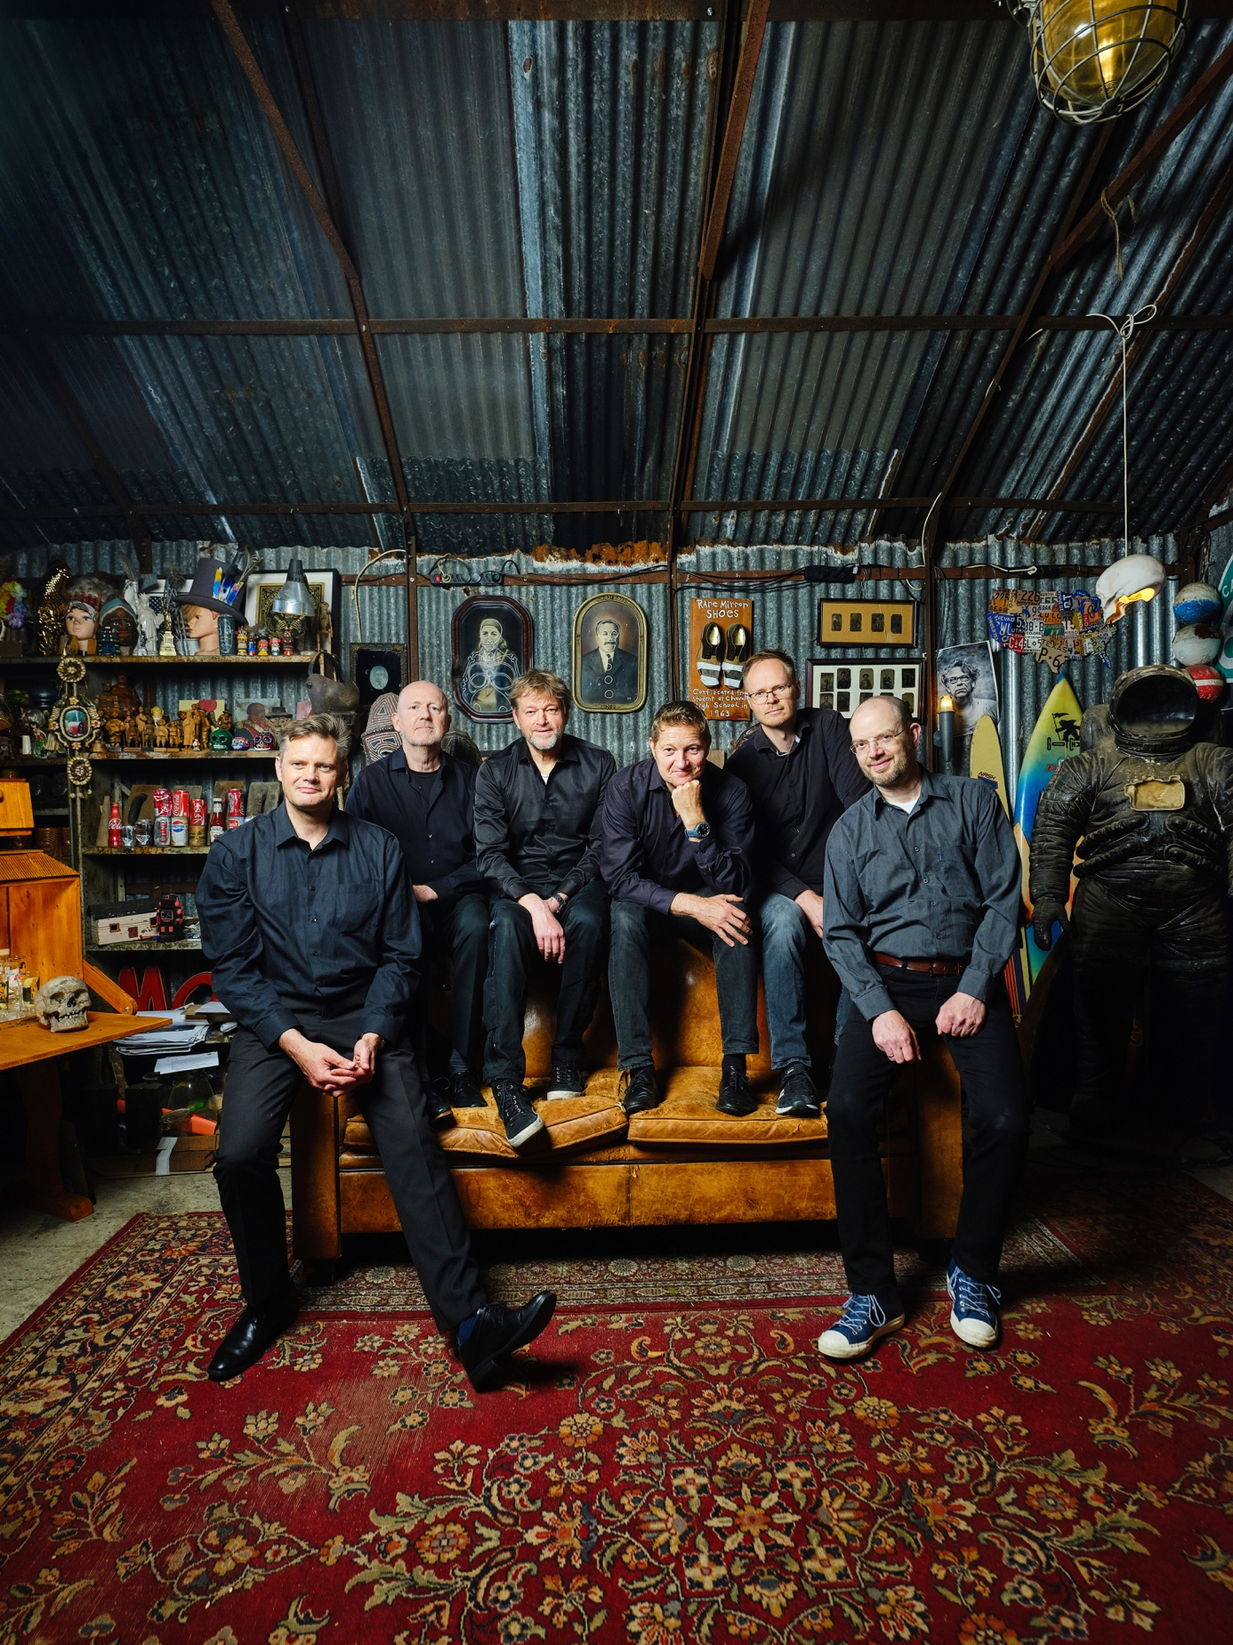

Logo's green'ish

Logo's grey'ish

Album cover
